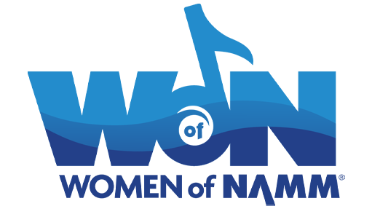

**Women of NAMM (WoN) Show Scholarship program**

**Application Guidelines**

**Women of NAMM (WoN) Mission:** The Women of NAMM (WoN) Fund was created in 2018 to expand diversity, inclusion, and support for women in the music products industry.

**Overview: The** **WoN NAMM Show scholarship program** seeks to support women with goals to connect, support and grow as professionals and leaders, and contribute to the development of the music products industry.

**WoN NAMM Show Scholarship Program Statement of Purpose:** The WoN Fund scholarship program supports women working in the music products industry and their goals to connect, support and grow their leadership and professional abilities.

**Award:**

* Up to Six (6) scholarships awarded.
* A one-time stipend of $1,500 to support attendance and participation at The 2024 NAMM Show
* Award supports travel-related expenses for attending The NAMM Show
* Award winners are recognized at The WoN reception during The NAMM Show
* Stipend payment is made as a reimbursement after the show and upon completion of the required post event report.

**Timeline:** The application period opens on Aug. 8 and closes Oct. 3. Applications are accepted through the online application portal. Award winners will be notified on Oct. 17.

|  |  |  |  |
| --- | --- | --- | --- |
| **Application Opens** | **Application Closes** | **Award Notification** | **Report Deadline** |
| Aug. 8 | Oct. 3 | Oct. 17 | Feb. 12, 2024 |

**Eligibility Requirements:**

* Women who have at least three years of experience working in the music products industry and seek opportunities to expand their leadership and professional competencies.
* Applicants should model the mission of WoN to Connect/Support/Grow opportunities for themselves and all women in the music products industry.
* Priority is given to women who have not attended a NAMM Show to provide an educational and NAMM emersion experience. See requirements of attendees
* Must work for a NAMM member company.

**Scholarship requirements:**

* Participate in at least four Idea Center sessions.
* Attend at least two NAMM U Breakfast sessions.
* Three hours of job shadowing at The NAMM Show with WoN-affiliated women leaders.
* Attendance at the WoN reception; scholarship recipients will be recognized.
* Submit a post-show report that summarizes activities and take-aways from The NAMM Show attendance; award will be paid upon submission and review of this report.
* Participate in a year-long mentorship program following the show, where you will be paired with industry veterans who will guide you in your professional journey.

**How to Apply:**

Please read the guidelines before completing all requirements through The NAMM Foundation’s online application system. An incomplete application will not be considered. The deadline to apply is Oct. 3.

**Step 1:** Go to https://www.cybergrants.com/pls/cybergrants/ao_login.login?x_gm_id=2807&x_style_id=&x_proposal_type_id=88732

**Step 2:** Log in or Create an Account

**Step 3:** First-time Cybergrants user, click on “Create your password” to set-up an account.

See below.

**IMPORTANT NOTE:** For the field “Organization,” please enter your First and Last Name, and not your company name.

**CONTACT INFORMATION**

Name:

Address:

Company:

Phone:

Email:

Website:

Occupation:

Job Title:

Entry year into the Music Products Industry:

* Companies you have worked for and dates:

Month & Year started with company:

Last NAMM Show attended:

**NARRATIVE:** Connect/Support/Grow

1. Describe your current role and responsibilities; include name of current employer and years employed, upload a CV/resume if desired.
2. Have you attended the NAMM show before? If yes, what year did you attend?
3. What do you hope to gain from your attendance at The 2024 NAMM Show that will help you in your current job?
4. Describe your professional goals for the next 1-5 years and what help are you seeking to support these goals?
5. What do you value most about the music products industry? Why?
6. Identify someone within the music products industry who has helped to positively influence you and how they have done so?

**Upload current resume:**

**Two Letters of Support:** Upload two letters of support from current employer (manager, supervisor) and/or colleague